
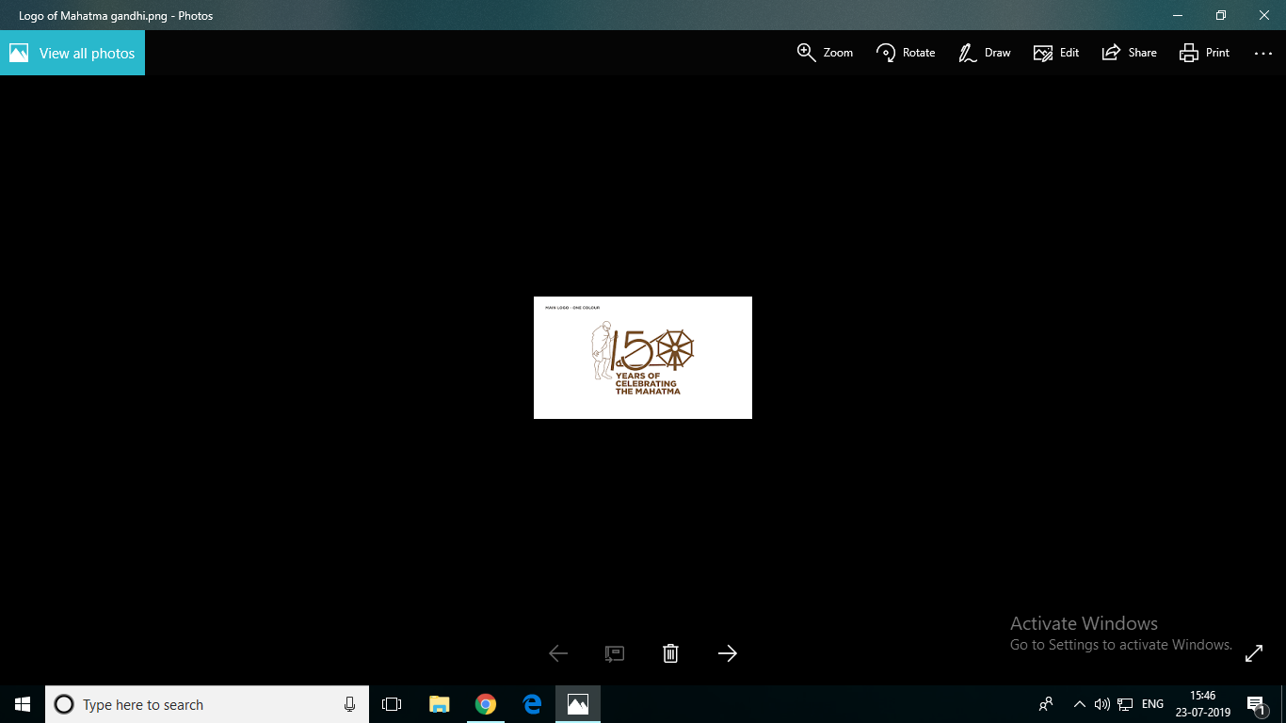
PSPCL PUNJAB STATE POWER CORPORATION LIMITED
(Regd. Office: PSEB Head Office, The Mall, Patiala-147001)
Corporate Identity Number: U410PB2010SGC33813
Website: www.pspcl.in

CORRIGENDUM NO. 2

Tender Enquiry No. 537/GHTP/EMC/GMMC-102 Dated: 18/12/2020.
Short Description: Award of running contract for rewinding of stator/ rotor of 220V DC motors (upto 8.5kW rating); three phase, 415 V AC squirrel cage motors (upto 75KW rating)/ slip ring induction motors (below 55kW rating) and three phase, 415 V AC submersible pump motors/ special motors of assorted ratings installed at GHTP, Lehra Mohabbat. Date & time for request for registration of Contractors/ Firms with GHTP shall be received 24/02/2021 upto 17:00 hrs. Date & time for receipt of request for issue of tender documents shall be received 02/03/2021 upto 17:00 hrs. Date & time up to which tender shall be received 09/03/2021 & 11:30 AM. Date & time of opening of tender 09/03/2021 & 12:00 PM.
Tender Specification can only be downloaded from PSPCL website https://pspcl.in and hard copy of the same will be issued by the office.

Note:- It is informed that in case tender process is not completed due to any reason no corrigendum will be published in newspapers. Details regarding corrigendum may be seen on PSPCL official website i.e. https://pspcl.in.

Dy. Chief Engineer,
Elect. Mtc. Circle, O&M,
GHTP, PSPCL, Lehra Mohabbat,
Ph. No. 0164-2756427.

